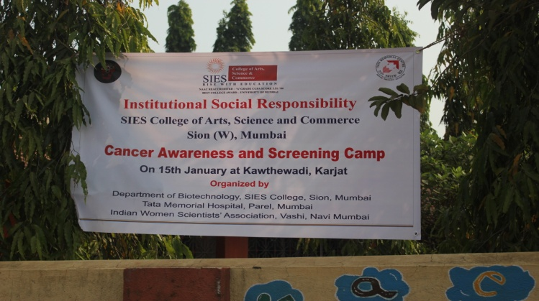
A Cancer Awareness and Screening camp was organized by the Department of Biotechnology and the Department of Preventive oncology, Tata Memorial Hospital under the aegis of ISR, SIES College. This cause was supported by the Indian Women Scientists’ Association (IWSA), Navi Mumbai. The Department of Preventive Oncology was represented by Doctors, senior medical social workers and health workers. They impressed upon the villagers the requirement for oral hygiene including the perils of smoking and tobacco chewing. They were also educated about the causes and incidences of breast and cervical cancers in addition to the importance of its early detection. A total of 96 villagers were screened for oral and breast cancers. Thirteen were reported as screen positive. Detailed report is awaited following which the future course of action can be decided upon
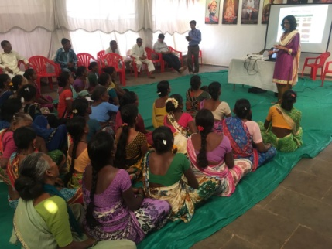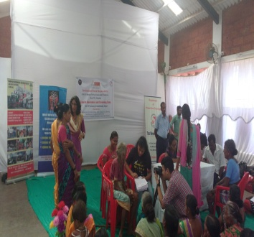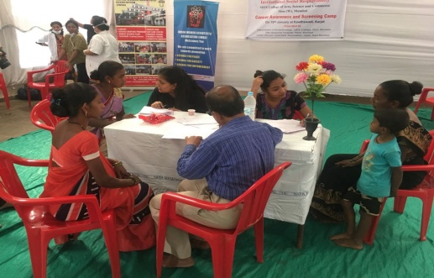
IWSA was represented by six scientists who have retired from institutes of national repute such as BARC, ACTREC and ICT. With a lot of enthusiasm they introduced the school children to the wonders of Science. They explained the importance of electricity, its generation, conservation and application through small experiments. They taught them the importance of personal hygiene by analyzing the dirt in their nails using a microscope. Through power point and You tube presentations the children were also taught the importance of organic farming and preparation of jaggery from sugar cane.
